**LabManual :Threats & Vulnerability , Risk Assessment And Reporting Using MBSA**

1. **Goto Windows web browser and search “https://www.techspot.com/downloads/downloadnow/3886/?evp=74be0290e6ee9ba69d6d78c76620bf51&file=4049#google_vignette”** 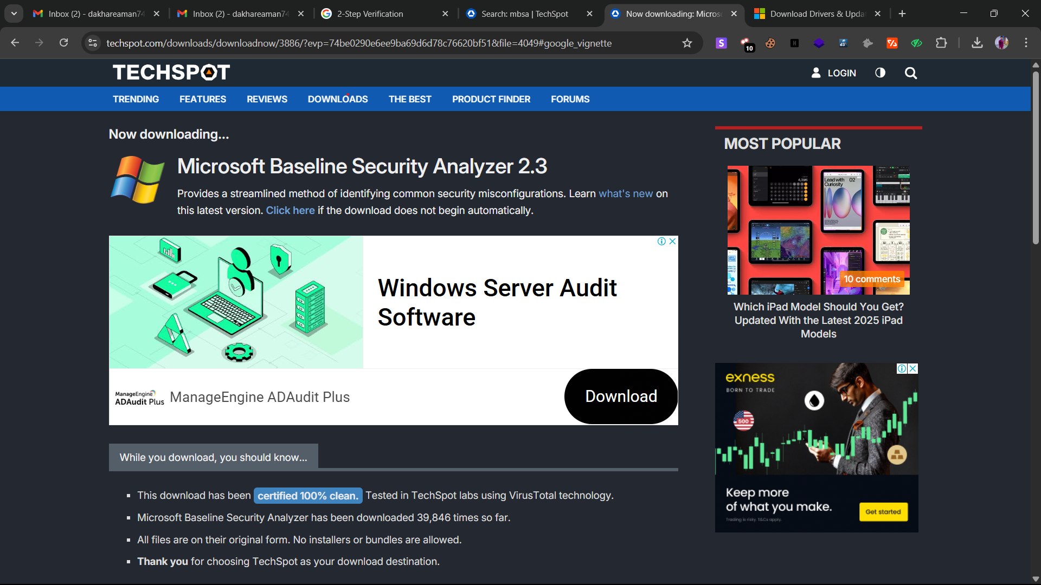
2. **Allow Unverified Download**
3. **After Download you will see the Tool in your Download Folder** 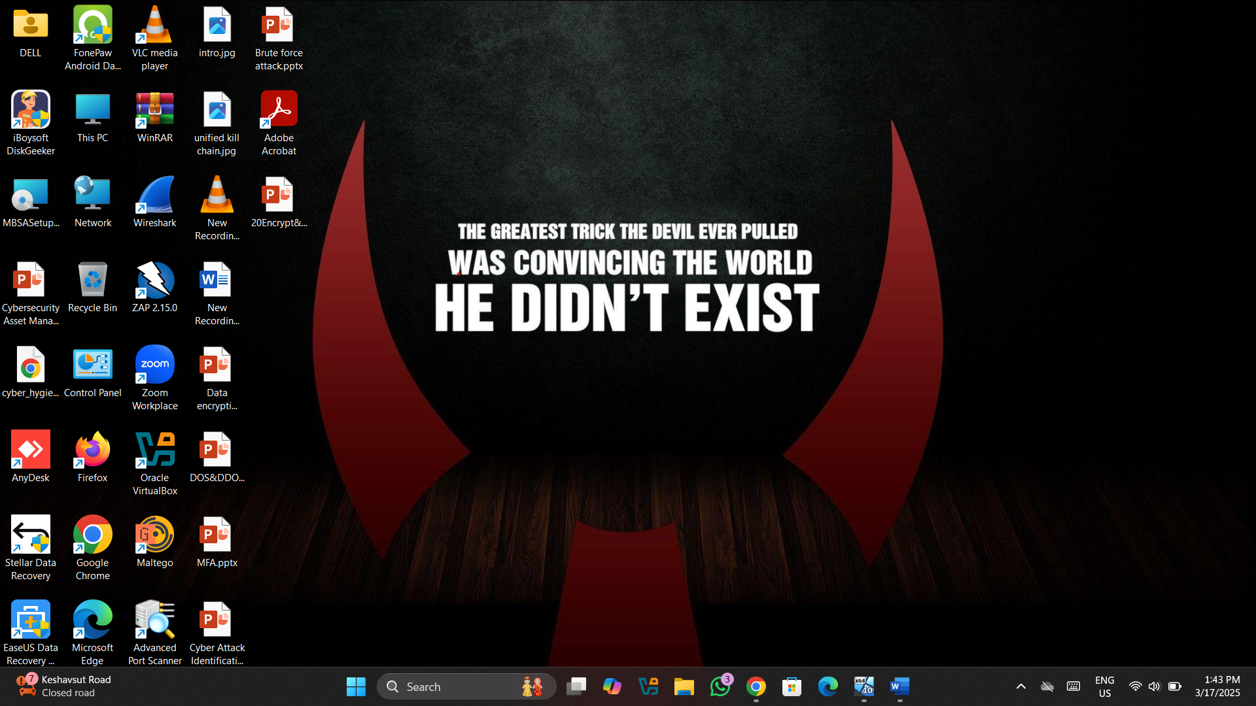
4. **Moving to Installation Process Double click on that Tool , You will see This window Click on nextA computer screen shot of a computer

   AI-generated content may be incorrect.**
5. **Click on I accept A screenshot of a computer

   AI-generated content may be incorrect.**
6. **Destination Folder is Keep to be Defualt And click next** 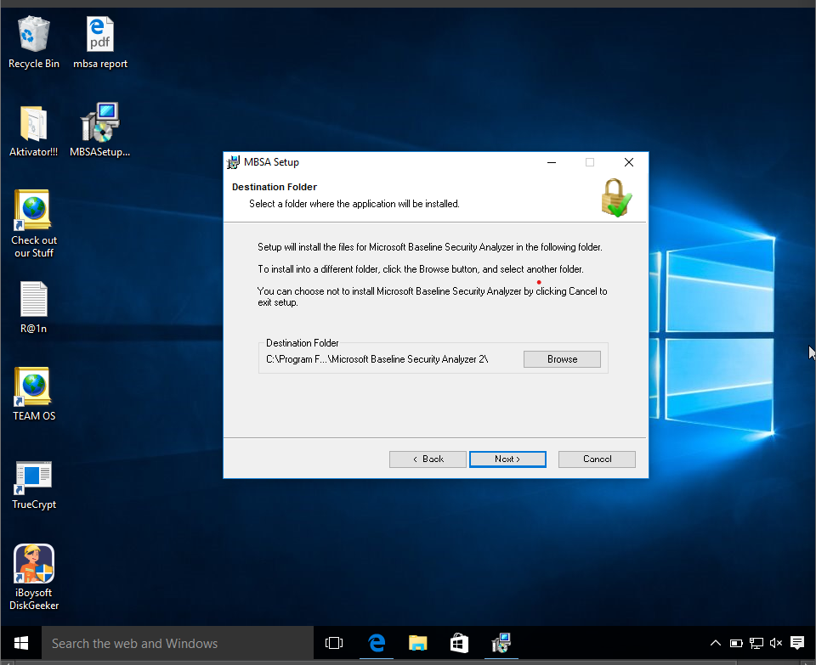
7. **Click On Yes**

1. **The tool has been Installed Successfully** 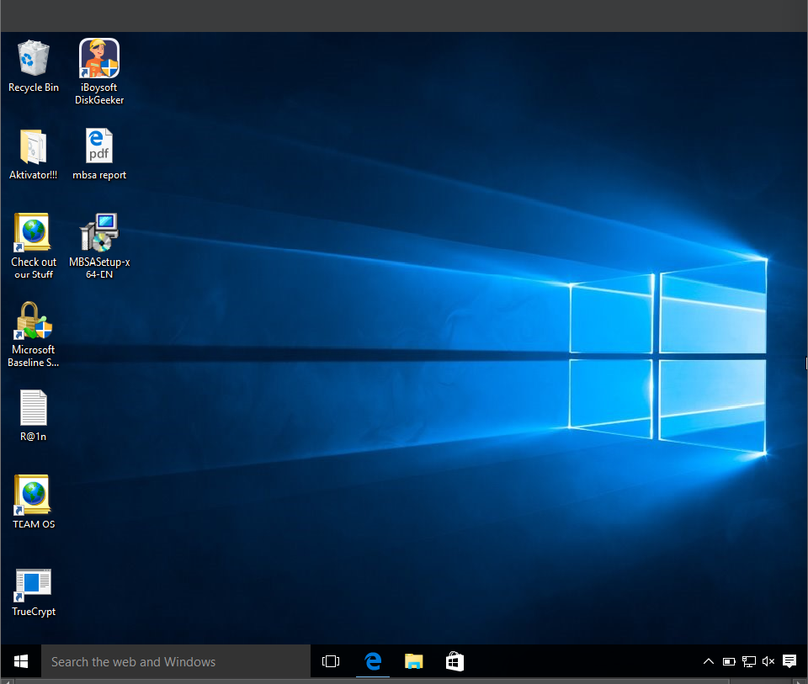
2. **Open The Tool A screenshot of a computer

   AI-generated content may be incorrect.**
3. **Click On Scan A Computer A screenshot of a computer

   AI-generated content may be incorrect.**
4. **Save it Default and Start ScanA screenshot of a computer

   AI-generated content may be incorrect.**
5. **The process of Scanning has been Started A screenshot of a computer

   AI-generated content may be incorrect.**
6. **The Report has been Generated If you want to save report click on Print this Report A screenshot of a computer

   AI-generated content may be incorrect.**